VERIZON – EVENT SCHEDULING
2024 02 07

Attendees:
- Global Technology:
  - Kristen Baum: Sr. Product Manager
    - Product Manager for the UXP project, leading the meeting
  - Luis Bustos: Director, Technology Architect & Strategy
    - Data Architect for the UXP project, explaining the features and integrations
- Verizon Team:
  - Joe Mannarino: Director Business Leadership
    - Business leader for Verizon, providing feedback and information on the event data and process
  - Alex Tarlow: Manager, Business Leadership
    - Business leader for Verizon, providing feedback and information on the event data and process
  - Erik Alden: SVP Group Dir Bus Leadership
    - Business leader for Verizon, providing feedback and information on the event data and process
  - Paulina Rubin: Sr. Mgr Business Leadership
    - Business leader for Verizon, providing feedback and information on the event data and process

Minutes:
- Discussed the UXP purpose, which aims to centralise and streamline the data from different sources and platforms for events management and reporting.
- Discussed the current process and data sources for Verizon events, and the challenges and opportunities they face.
- Suggestions about having an intake form for out-of-scope events that could also generate an estimate based on a rate card and some assumptions.
- Clarifications on how Brandscopic would be used for field data collection and recapping, while UXP would be used for event scheduling and analytics.
- They raised the need for a visual and intuitive way to manage the routing and logistics of the tour events, and to see the gaps and opportunities in the schedule.
- They asked about the possibility of having inventory management in the UXP, and the integration with other systems that capture information such as URL creation, QR codes, and surveys.
Action list:
- Kristen and Luis to look into the intake form and estimate feature and how it could be implemented in the UXP.
- Joe, Alex and Erik to start working on exporting and importing the event data into Brandscopic and provide feedback on the fields and recap questions.
- Luis to explore the different views and cues for the events based on status, region, and missing information.
- Luis to check the integration options with inventory management systems and other data sources.

FEEDBACK GATHERED AND REQUIREMENTS

Joe’s raised requirements:
- Simplify the process of estimating the cost of physical assets by having a ballpark price and a drop-down menu.
- Automatically generate a rate card and an estimate based on the intake form for out-of-scope events.
- Track the inventory of premiums and other assets and alert him of any opportunities or issues.
- Create and attach QR codes to events or programmes and provide the scan data in a timely manner.
- Capture and report the leads from loop calls and email capture.
- Provide a calendar view of the events with different colour codes and visual cues for status and missing information.
- Attach files such as site maps and BA talking points to events and compile them into a call sheet.

Alex's raised requirements are:
- An intake form for out-of-scope events that can capture the relevant information from the client and translate it into an estimate.
- Streamline the data collection from different sources (field managers, QR codes, etc.) and provide better insights and reporting.
- A way to reduce the manual work and the backlog of creating estimates and rate cards for each event.
- Create QR codes and URLs automatically and link them to the events and campaigns.
- Provide an air traffic controller view of the tour schedule and allow the associates to see the routing, the off days, the load-in and load-out details, and the opportunities to fill the gaps.
- Attach files such as site maps and BA talking points to the events and generate call sheets.
- Colour-code the events by status and region and alert the user of any missing information.
- Integrate with the survey platform and provide the data on scans, leads, sales, and engagements as soon as possible.

Erik’s raised
requirements:
- Scan data and the leads data from the QR codes and the common back end as soon as possible after the events.
- Change the reporting cadence and provide the client with some key metrics such as scans, leads, engagements, and sales on Monday at 1 pm.
- Avoid having to manually clean the data from the different systems.
- Have an inventory management system that can track the number of key chains and other premiums that are given away at the events.

Requirements table:

Overarching Theme | Category | Item | Requester | MVP | v1+ | Other platform | Complexity
Data Management | Data Collection | Intake form for capturing client information | Alex | ✓ |  |  | Medium
 | Data Integration | Streamline data collection from various sources | Alex | ✓ |  |  | High
 | Data Reporting | Provide key metrics report by Monday at 1 pm | Erik |  |  | ✓ | Medium
 | Data Cleaning | Avoid manual data cleaning from different systems | Erik | ✓ |  |  | Medium
UI/UX | Event Visualization | Calendar view of events with colour codes | Joe | ✓ |  |  | Medium
 |  | Colour-code events by status and region | Alex | ✓ |  |  | Low
 | QR Codes | Create and attach QR codes to events | Joe | ✓ |  |  | Medium
 |  | Automatically create QR codes and URLs for events | Alex | ✓ |  |  | Medium
 | Tour Schedule | Air traffic controller view of tour schedule | Alex | ✓ |  |  | High
Operational Efficiency | Manual Work Reduction | Reduce manual work in creating estimates and rate cards | Alex |  | ✓ |  | High
 | Cost Estimation | Simplify process of estimating cost for physical assets | Joe |  |  | ✓ | Medium
 | Inventory Tracking | Track inventory of premiums and assets | Joe |  |  | ✓ | High
 | Inventory Management | Track giveaways and premiums at events | Erik |  |  | ✓ | High
Documentation & Lead Management | Documentation | Attach files to events and compile into call sheet | Joe | ✓ |  |  | Medium
 | Lead Capture | Capture and report leads from loop calls and email | Joe | ✓ |  |  | Medium
 | Rate Card & Estimates | Automatically generate rate card and estimates from intake form | Joe |  |  | ✓ | High
Inventory | Inventory Management | Track giveaways and premiums at events | Erik |  |  | ✓ | High

Event Status:
- Proposed: The event has been pitched to the client but not yet approved.
- Tentative: The client has approved the event but the logistics are still being worked out.
- Confirmed: The event has been finalised and is ready to be executed.
- Cancelled: The event has been cancelled for some reason.
- Completed: The event has been executed and reported.
Current Tool kit routing
- In Google Sheets:
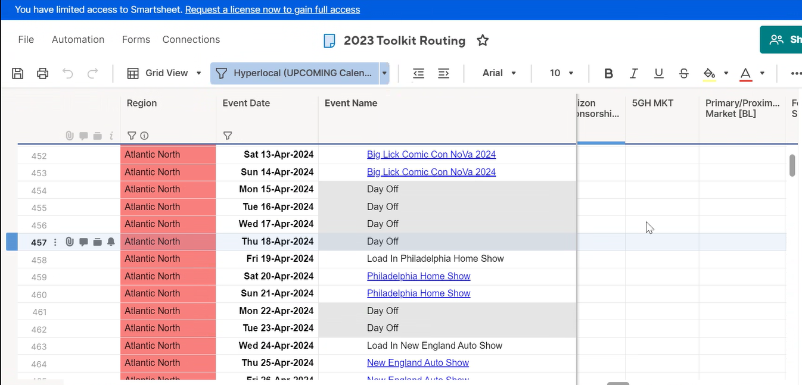
- In Smartsheet

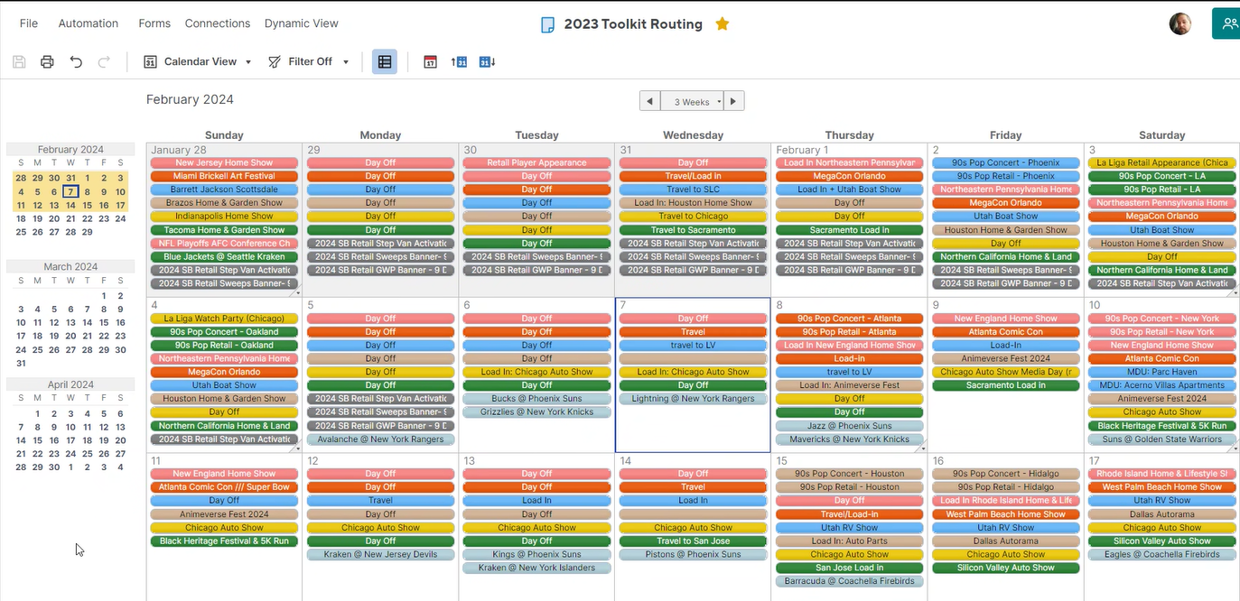

Luis’ questions:
- What does the client request look like? Is it completely formulated once? Once they, they request us some work? Or is it a heads-up originally and that's been shaped as the weeks progress? Or how does it work?
  - Alex answered that for in-scope events, they have a good cadence of planning and selecting the events, but for out-of-scope events, they are haphazardly collecting the information and they would benefit from an intake form that can compile and estimate the information.
- In which format do currently rate cars exist? Is that spreadsheet or are there in in vantage in theory?
  - Joe answered that they have a rate card for people, but they are trying to simplify the process of estimating the cost of physical assets by having a ballpark price and a drop-down menu.

Email from Alex with responses before meeting:
- What tools or methods are currently used for tracking events
  - SmartSheets – used mainly by BL and Analytics to compile event details for both scheduling and reporting
  - Google Sheets – used internally and externally for organization and Verizon tracking (ie Master Routing Doc)
- Who are the key stakeholders involved in the event planning
  - Scheduler – all BLs
  - Event Details – BL + XP
  - BA or Staffing - BL
  - Recap data – Analytics + BL
- Event Metrics
  - What data is reported to client
    - Venue, Zip Code, Region, Activation Type, Event Type, Vertical, Attendance, Impressions, LQA, LQS, Surveys, QR Scans, Premiums, Sales, Lead Gen, Activation Days
  - How is data collected from events
    - Sales, Premiums Distributed = reported by Field Managers to BLs for input into weekly Analytics report
    - Venue, Zip, Region, Activation Type, Event Type, Vertical, Attendance = inputted by BL into SmartSheets
    - LQA, LQS, Surveys, QR Scans, Lead Gen = compiled by Analytics
  - What is challenging in your process
    - Ensuring data points needed by other teams (Analytics, XP) are collected and inputted before reports are pulled
- Integrations that exist, if applicable
  - Unsure what this question is asking
- Features and Functionality:
  - What features do you think would streamline the event planning and tracking process for you?
    - Ensuring any solution allows for an ‘air traffic controller’ view – a view that shows all events across multiple regions/event types to see quickly:
      - 1) routing for tours makes sense
      - 2) event proposals – ie, where do BL associates see the tour going next
      - 3) ability to quickly see missing information such as load-in details, activation hours, etc.
  - Are there specific functionalities that you consider essential for your role managing events?
    - A grid-like view of all events. A calendar view does not suffice and quickly gets messy if it cuts off event details. Seeing only event names does not allow BL to see potential routing issues.

